After setting your goals, outline the steps you will take to achieve the goals. On the EDFS website, you will be asked to explain the supports or resources you will need and specify a timeline or frequency for each action step that you enter. The screen will look like this:
Action Planning Worksheet
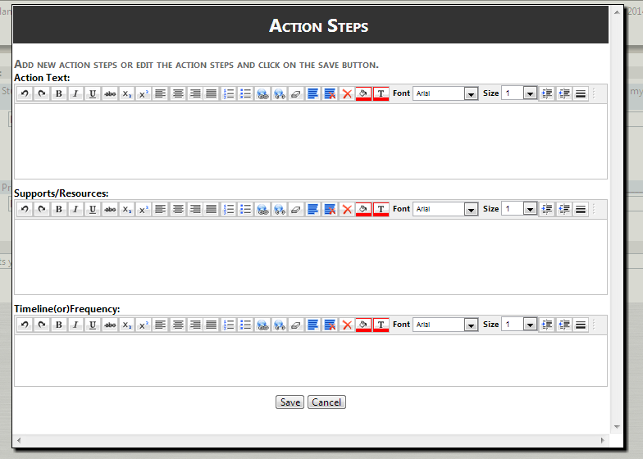

Three to five action steps are suggested for each goal. If your student learning and professional practice goals are closely related, you can use the same action steps for both of them. The EDFS website will ask you to enter them separately for each goal, so it is best to use the charts below to type them first, and then copy and paste into the pop-up boxes.

When your action plans are complete, you will submit them for your evaluator to review in the same manner that you submitted goals.

Goal:

Action Text: | Supports/ Resources: | Timeline (or) Frequency:

Goal:

Action Text: | Supports/ Resources: | Timeline (or) Frequency:

